JAVA MINI PROJECT
Name: Rudrakshi Bhandekar
Prn: 24070521012
Sem: 4th A
Topic: Student Management System

1. Student Management System
Problem Definition;
Design a Java program to manage student information using inheritance. Create a base class Person that stores common details like name and age. Derive a class Student that includes additional attributes such as roll number and marks. Further extend it into another class GraduateStudent with specialization details. The program should display complete student information using inherited properties.
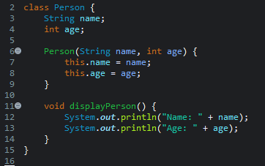
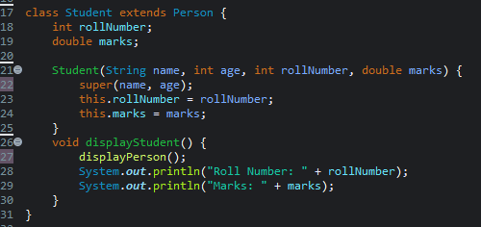
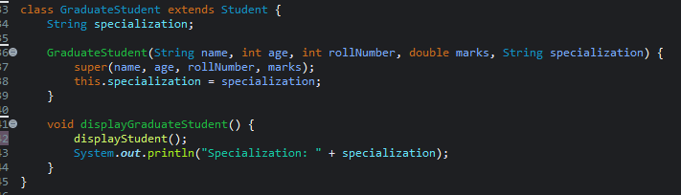
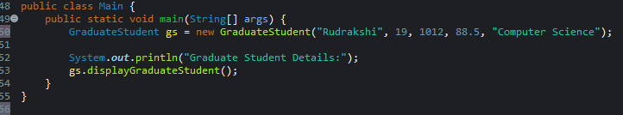
OUTPUT:
